Relationships in MS Access
A relationship links records in two tables through a common field, so that data is stored once and connected rather than repeated
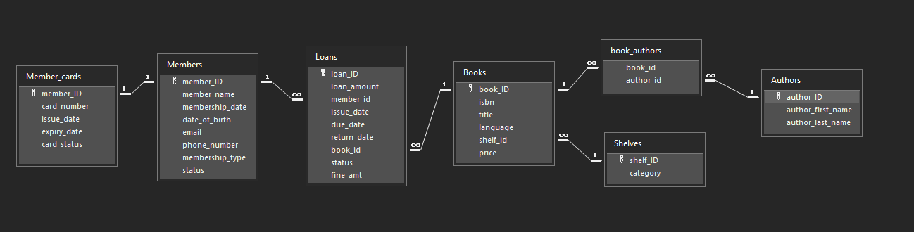

Types of Relationships:
One-to-one (1:1):
One record in Table A matches at most one record in Table B, and vice versa. It’s used to split rarely-used or sensitive data into its own table.
Example: each member has one library card, and each card belongs to one member.
In Access it’s created by linking the primary key of Members to the primary key of Member_Cards. Both sides are unique, so a duplicate card for the same member is rejected.
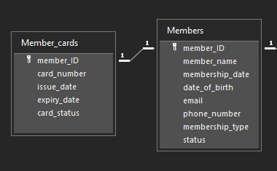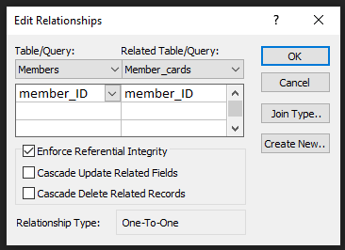
One to Many (1:M):
One record in Table A can match many records in Table B, but each record in B matches only one in A. It’s the most common type.
Example: one member can borrow many books over time, but each loan belongs to one member.
In Access, Members.member_ID (primary key, the “one” side) is linked to Loans.member_id (foreign key, the “many” side). The same applies to Shelves → Books and Books → Loans.
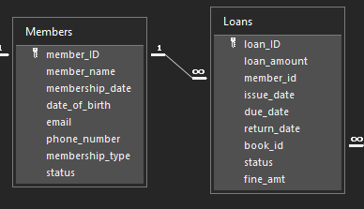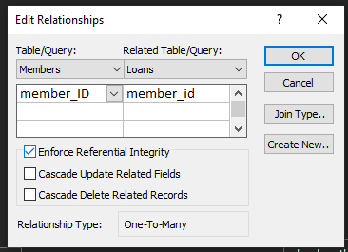
Many to Many (M:M):
Records in A can match many in B, and the reverse. Access can’t create this directly, so a junction table is needed that holds the primary keys of both tables as foreign keys.
Example: a book can have several authors (Database System Concepts has three) and an author can write many books.
book_authors holds book_id and author_id as a composite primary key, with a one-to-many link to Books and another to Authors. Together these two links form the many-to-many relationship.
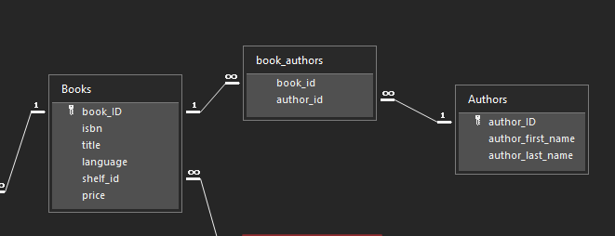

Importance of referential integrity
Referential integrity is a rule that stops a foreign key from pointing to a record that doesn’t exist. When enforced, Access:
- blocks you from adding a loan for a member_id or book_id that doesn’t exist (no “orphan” records);
- blocks you from deleting a record in the “one” table while related records exist in the “many” table;
- blocks changing a primary key value that other tables depend on.
Without it, a loan could point to a deleted member, reports would show blank names, and the database would become unreliable over time.

Deleting a member who still has active loans
With referential integrity enforced and Cascade Delete off (the default), Access refuses the deletion and shows an error similar to: “The record cannot be deleted or changed because table ‘Loans’ includes related records.” This protects the library’s records, since the books still on loan can’t be traced back to anyone.
The correct approach is to return the books first, or set the member’s status to Inactive instead of deleting.
If Cascade Delete Related Records were enabled, deleting the member would silently delete all their loans too, which is dangerous because it destroys borrowing history. That’s why it’s usually left off for this relationship.

